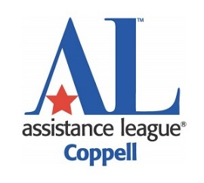

Assistance League of Coppell® 2025-2026 Scholarship Application
Letter of Recommendation

Name of Student:

Student’s Email (if available)

Author of Letter:

Author's Phone: Author’s Email Address:

Author’s role in the Project/Organization:

Are you related to the applicant? If so, what is the relationship?

To promote and reward community service in our youth, Assistance League of Coppell is proud to offer $1,000 scholarships to three (3) graduating high school seniors who have exhibited an interest in philanthropic work and have given of their time and talents to improve their community.

Instructions for person writing letter of recommendation:

- This recommendation must be from an organization for which the applicant has volunteered and not received any financial compensation or received school credit.

- The deadline to submit the letter of recommendation is March 31, 2026.

- The letter must be sent by you, the author of the letter of recommendation. Please do not forward it to the applicant for submission.

- Please include this cover sheet along with your letter of recommendation.

- Email your letter of recommendation and cover letter to alcoppellscholarship@gmail.com.

- To help us get to know the applicant, please include in your letter:
- How the applicant served within your organization and their responsibilities
- any self-initiated service projects the applicant completed
- details regarding the character of the applicant
- unique qualities the applicant exhibited while volunteering for your organization

- To make the selection process as fair as possible, we request that in your letter you refer to the student as “the applicant” and do not include the applicant’s name anywhere in the body of the letter.

If you have any questions, please do not hesitate to contact the Assistance League of Coppell scholarship chair at alcoppellscholarship@gmail.com.

